Dear PAMS members and Friends
Thank you for your involvement and support. 2014 has been a great year for our Society with many success stories!
2014 brought
- 24 Missions in Peru with hundreds of Peruvians helped to recover their health.
- We increased by 41 new members
- We merged PAMS and EF and our Society became logistically more nimble
- We had successful Business and Annual meetings in Miami and Iquitos
- We are going international, opening a Chapter in Mexico City
In 2015 we shall continue our momentum and continue to serve Peruvians providing assistance to their health and medical education
- Renew your membership or sign up for membership
- We have plans for 26 Missions, participate in at least one
- Donate funds, time, talent
- Become involved in a Committee
- Attend the PAMS Business Meeting April 17-19, Washigton DC
- Attend the Annual Meeting August 12-15, Chiclayo Peru
- Forward this email to all peruvians you know!
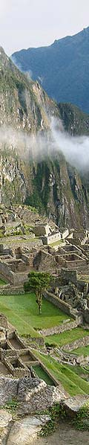
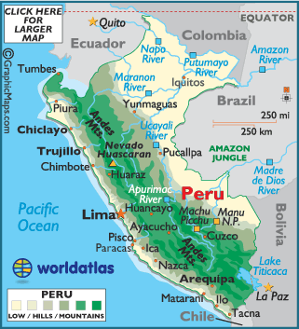 From the PAMSEF Board of Directors www.pamsweb.org
Have a Great Holiday Season and a Prosperous 2015

